

# 

COMPLAINT : 6

DATE: 18/Mar/2021

The Manager,

BANK AL-HABIB

ABC Branch,LHR ZONE

Subject: Quotation of Repair and Maintenance. FOR APPROVAL

Number of AC: 1

|  |  |  |  |  |
| --- | --- | --- | --- | --- |
| Sr. | Job Description | Qty | Rate | Amount |
|  | Monthly general Servicing (upto to 2 Ton) | 1 | 300.0 | 300.0 |
|  | Total |  |  | 300.0 |
|  | Tax 16% |  |  | 48.0 |
|  | Visit Charges | 5 | 780 | 3900 |
|  | Total |  |  | 4248.0 |

**Yours truly,**

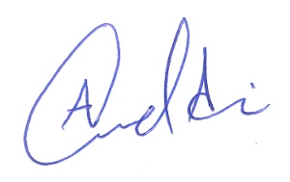 **ECO ENTERPRISES**